**Batch: H1_4 Roll No.:16010122083**

**Experiment 04**

|  |
| --- |
| **Title:**  Introduction to various charts |

# Objective:

# 1. To learn how to use various charts for visualizing preprocessed data

# Pie chart

# Donut chart

# Lollypop chart

# Boxplot

# Bubble chart

# Bump Chart

# Funnel chart

# Water Chart

# Bar chart /column chart / Stacked chart

# Area Chart

# Pareto chart

# Tree maps

# Scatter plot

# Gantt chart

# Word map

# 2. To learn following concepts

# Parameters

# Combine, Sets

# Label, Title and caption

# Working with metadata

# Working with filter

# Font, Size, colour, and Border,

# Calculated field, Number function, string function

# Conditional formatting, logical function

# Exporting the charts

# 3. To learn interpretation of each charts/plots

# Course Outcome:

# CO1: Learn how to locate and download datasets, extract insights from that data and present their findings in a variety of different formats.

# CO3: Apply data visualization best practices

# Books/ Journals/ Websites referred:

(Students should write)

The dataset was obtained from:

[**https://www.kaggle.com/datasets/bhanupratapbiswas/fashion-products**](https://www.kaggle.com/datasets/bhanupratapbiswas/fashion-products?resource=download)

[**https://www.kaggle.com/datasets/rushikeshhiray/esport-earnings**](https://www.kaggle.com/datasets/rushikeshhiray/esport-earnings)

# Resources used:

(Students should write)

Kaggle

Tableau

# Pie chart

# https://help.tableau.com/current/pro/desktop/en-us/buildexamples_pie.htm

# Donut chart

# https://www.analyticsvidhya.com/blog/2021/02/how-to-create-donut-chart-tableau/

# Lollypop chart

# https://www.tableau.com/blog/viz-whiz-when-use-lollipop-chart-and-how-build-one-64267

# Boxplot

https://www.tutorialspoint.com/tableau/tableau_box_plot.htm#:~:text=The%20box%20plots%20are%20also,quartiles%20of%20the%20data's%20distribution.

# Bubble chart

# https://www.tutorialspoint.com/tableau/tableau_bubble_chart.htm

# Bump Chart

# https://data-flair.training/blogs/tableau-bump-chart/

# Funnel chart

# https://www.tableau.com/blog/three-different-ways-build-funnels-tableau-and-why-89871

# Waterfall Chart

# https://www.tutorialspoint.com/tableau/tableau_waterfall_charts.htm

# Bar chart /column chart / Stacked chart

# <https://help.tableau.com/current/pro/desktop/en-us/buildexamples_bar.htm>

# Area Chart

# https://help.tableau.com/current/pro/desktop/en-us/qs_area_charts.htm

# Pareto chart

# https://help.tableau.com/current/pro/desktop/en-us/pareto.htm

# Tree maps

# https://help.tableau.com/current/pro/desktop/en-us/buildexamples_treemap.htm

# Scatter plot

# https://www.tutorialspoint.com/tableau/tableau_scatter_plot.htm#:~:text=As%20the%20name%20suggests%2C%20a,to%20create%20a%20scatter%20plot.

# Gantt chart

# https://help.tableau.com/current/pro/desktop/en-us/buildexamples_gantt.htm

# Word map

# https://help.tableau.com/current/pro/desktop/en-us/maps_howto_simple.htm

# Theory (About various charts explored):

(Students should write)

# LINE CHART: The line chart, or line graph, is method for displaying data. It connects several distinct data points, presenting them as one continuous evolution.

* PIE CHART : A pie chart is a circular statistical graphic which is divided into slices to illustrate numerical proportion.
* DONUT CHART: Donut charts are used to show the proportions of categorical data, with the size of each piece representing the proportion of each category.
* LOLLYPOP  CHART : A lollypop chart is a more visually appealing variation of a bar chart. The bar is replaced with a thin line and a circle at the end of it, making it resemble a lollypop.
* BOX PLOT : A box and whisker plot—also called a box plot—displays the five-number summary of a set of data.
* BUBBLE CHART : Bubble charts, also known as bubble plots or bubble graphs, are used when data needs a third dimension to provide richer information to viewers. A bubble plot is a relational chart designed to compare three variables
* BUMP CHART : A Bump Chart is used to compare two dimensions against each other using one of the Measure value. They are very useful for exploring the changes in Rank of a value over a time dimension or place dimension or some other dimension relevant to the analysis.
* FUNNEL CHART : A funnel chart is a graphical representation used to visualize how data moves through a process. In a funnel chart, the dependent variable's value diminishes in the subsequent stages of the process.
* WATER CHART: A nautical chart is one of the most fundamental tools available to the mariner. It is a map that depicts the configuration of the shoreline and seafloor. It provides water depths, locations of dangers to navigation, locations and characteristics of aids to navigation, anchorages, and other features.
* BAR CHART : A bar chart or bar graph is a chart or graph that presents categorical data with rectangular bars with heights or lengths proportional to the values that they represent.

# AREA CHART : An area chart or area graph displays graphically quantitative data. It is based on the line chart. The area between axis and line are commonly emphasized with colors, textures and hatchings

# PARETO CHART: A Pareto chart is a type of chart that contains both bars and a line graph, where individual values are represented in descending order by bars, and the cumulative total is represented by the line

# TREE MAPS : In information visualization and computing, treemapping is a method for displaying hierarchical data using nested figures, usually rectangles. Treemaps display hierarchical data as a set of nested rectangles.

# SCATTER PLOT : A scatter plot is a type of plot or mathematical diagram using Cartesian coordinates to display values for typically two variables for a set of data. If the points are coded, one additional variable can be displayed

# GANTT CHART :A Gantt chart is a project management tool assisting in the planning and scheduling of projects of all sizes; they are particularly useful for visualising projects. A Gantt chart is defined as a graphical representation of activity against time; it helps project professionals monitor progress.

# Word map : A word map is a visual organizer that promotes vocabulary development.

# Following points should be written by students

# Different charts explored for data visualization:

# Working: Using tableau software

# Exported of each chart output with variations explored on your dataset

# Interpretation (what each chart signifies)

**PIE CHART:**

# 

# STACKED GRPAH:

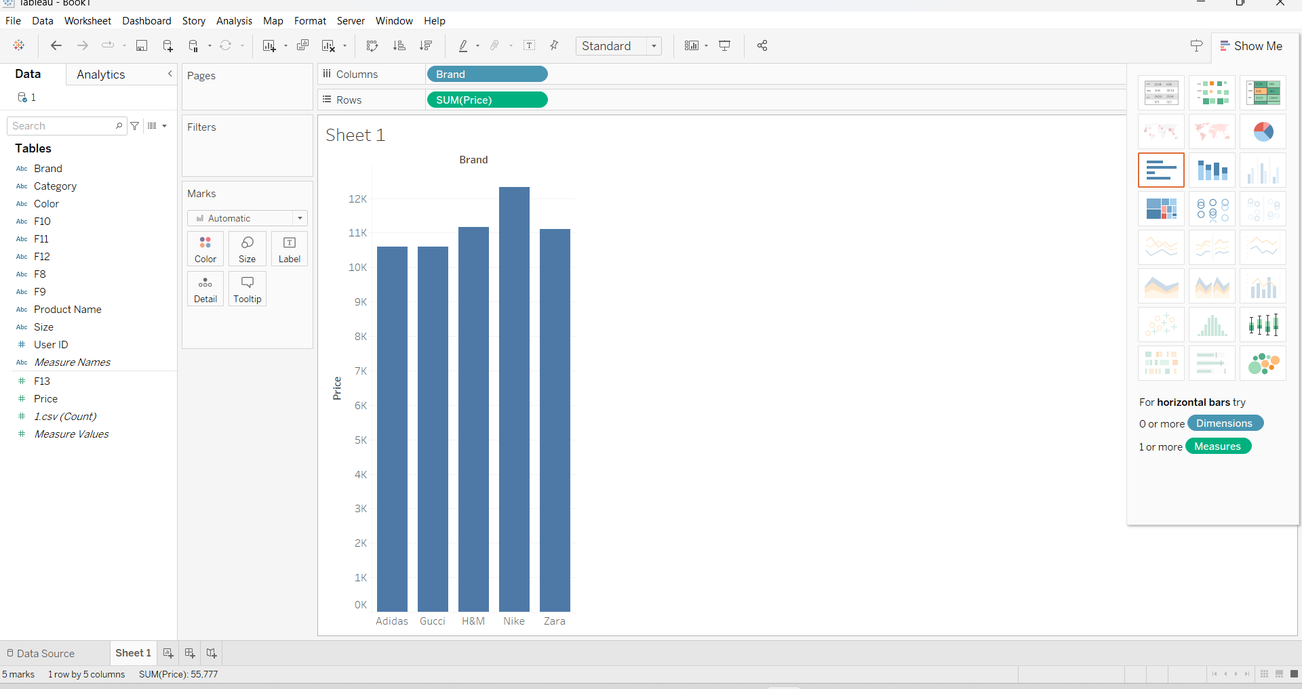

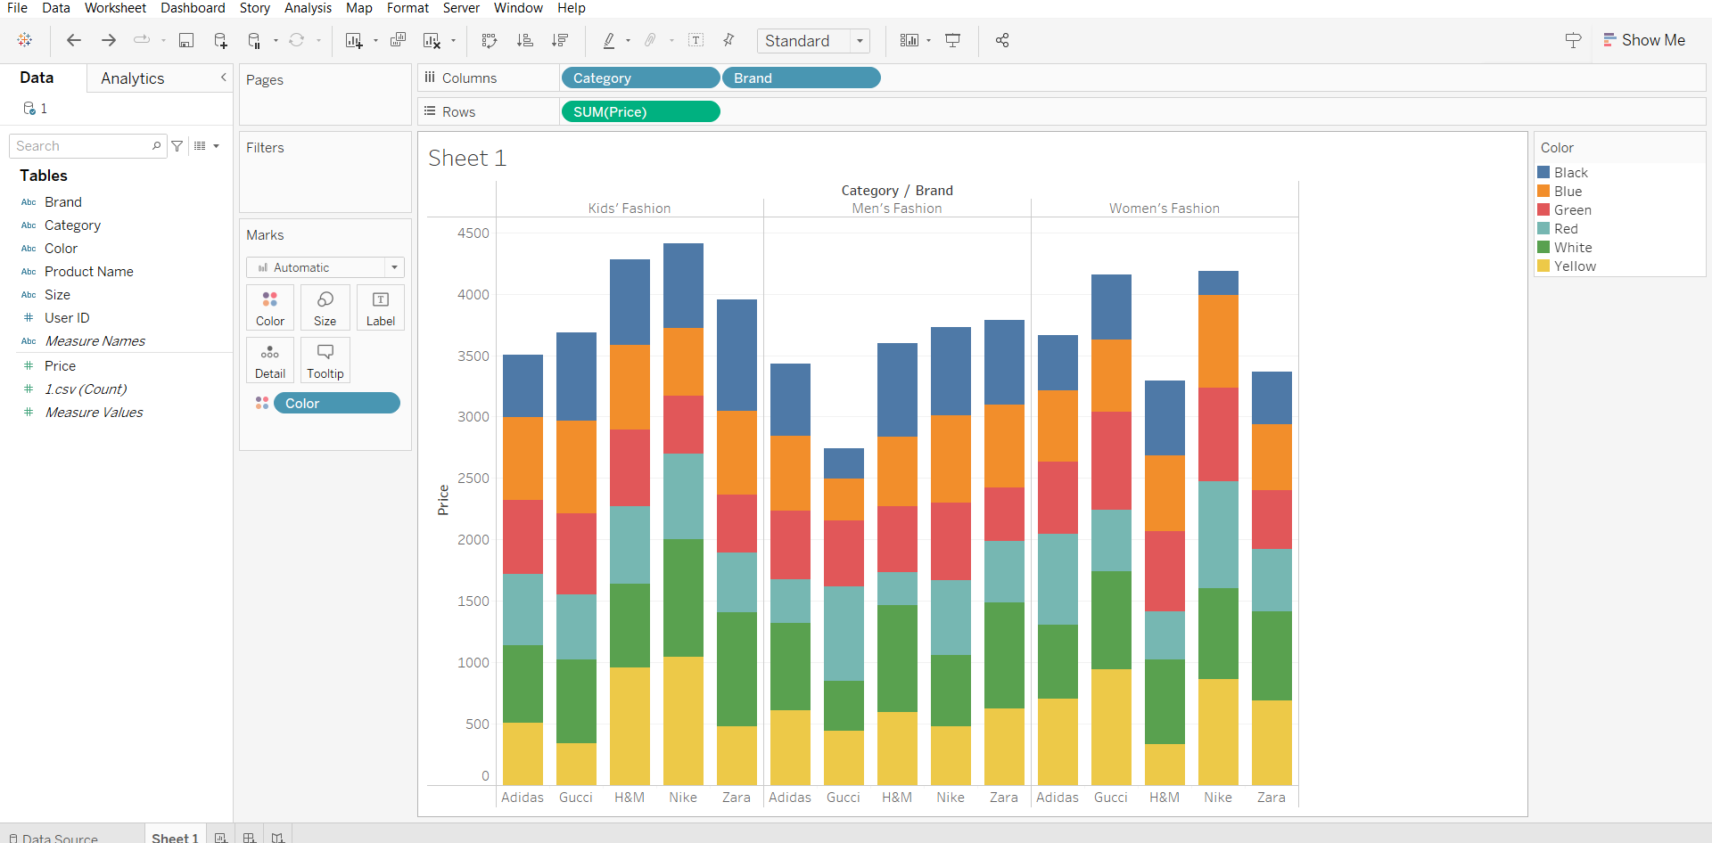

**TREE GRAPH:**

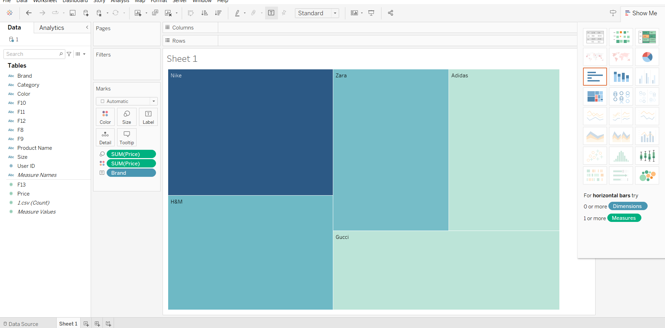

**CIRCLE VIEW GRAPH:**

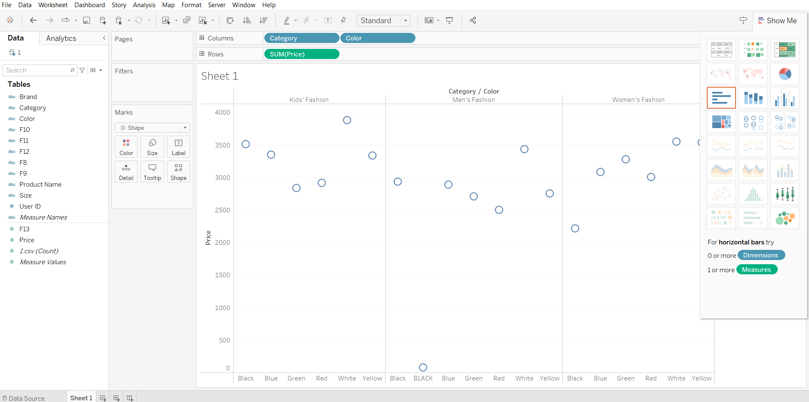

**SCATTER PLOT GRAPH:**

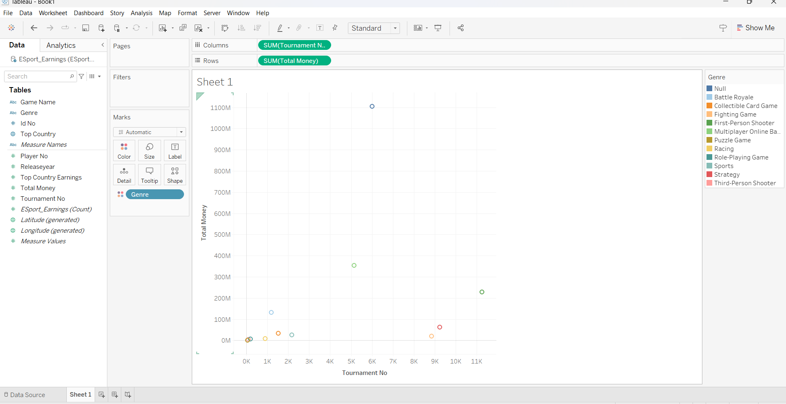

**BULLET GRAPHS:**

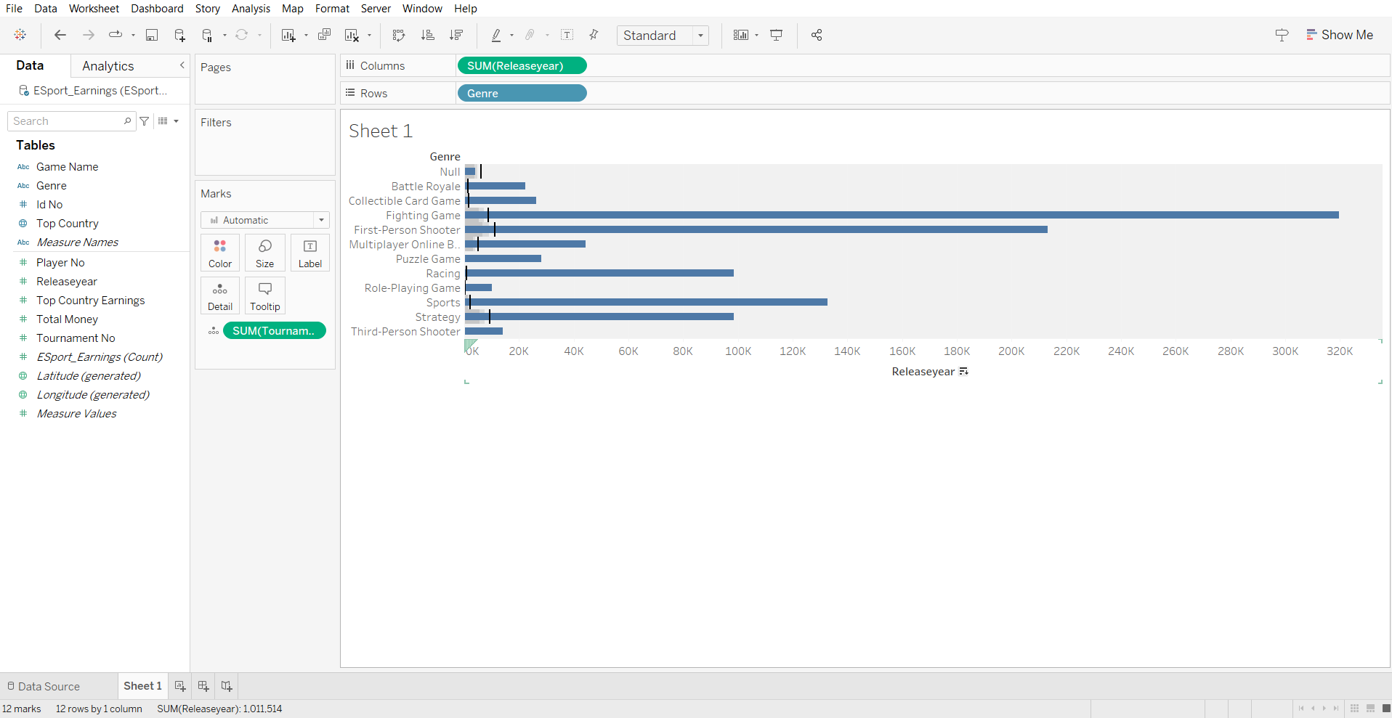

# TEXT TABLES:

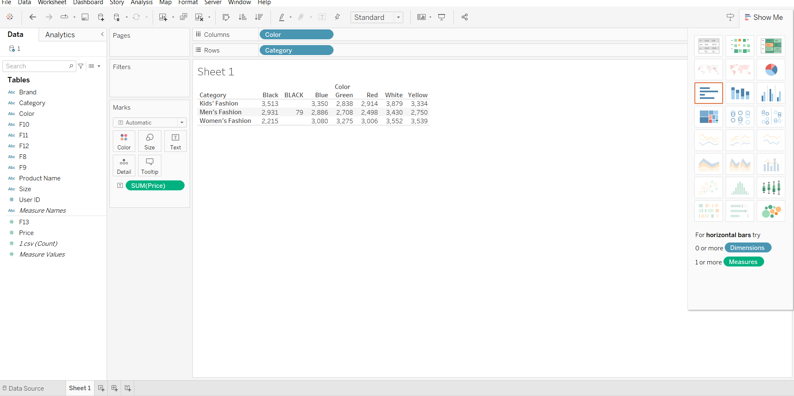

**SIDE-BY-SIDE CIRCLES:**

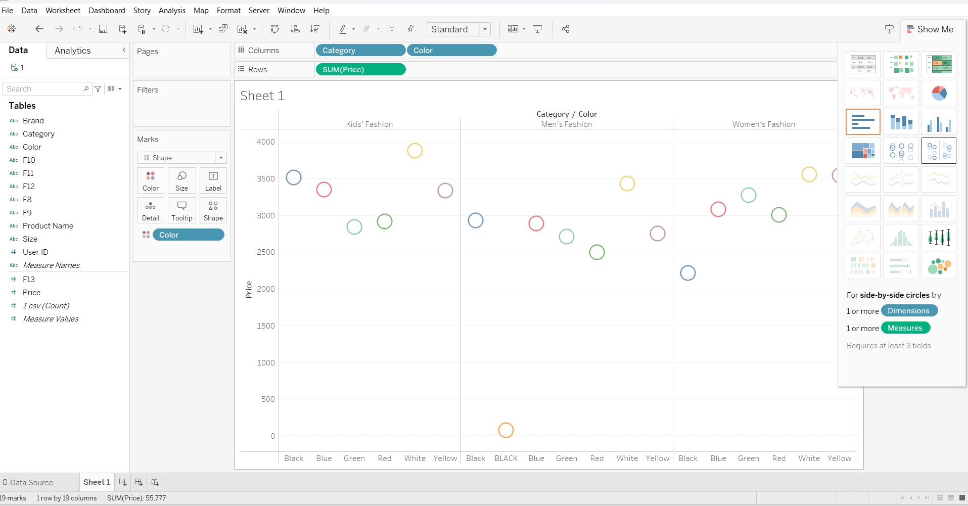

**PACKED BUBBLES GRAPH:**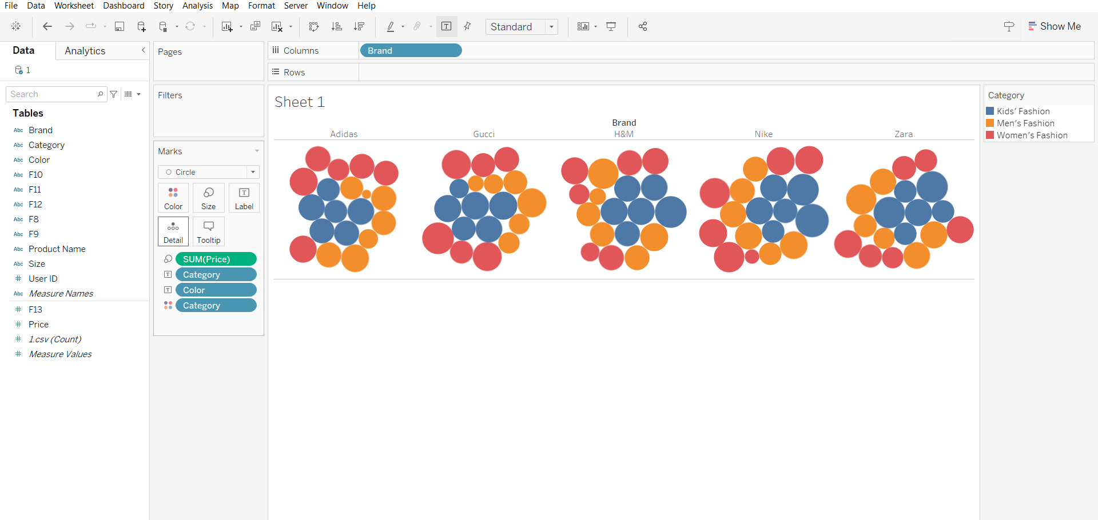

**SIDE-BY-SIDE BARS:**

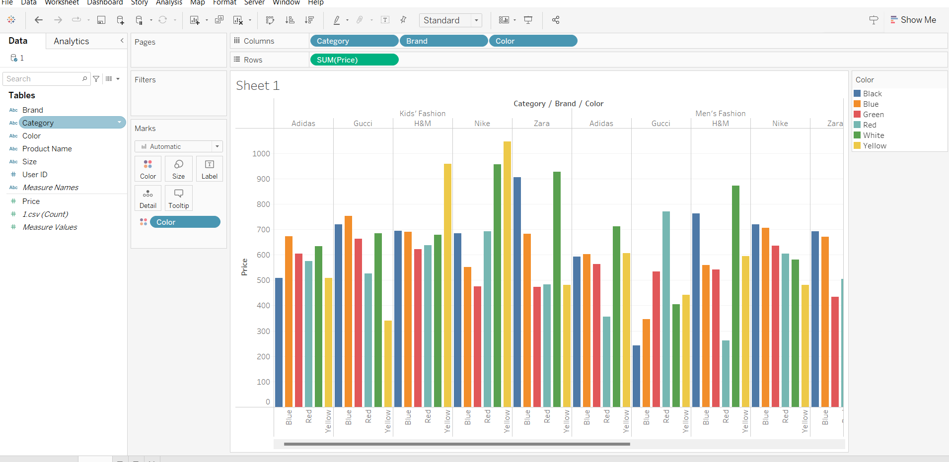

**HIGHLIGHT TABLES:**

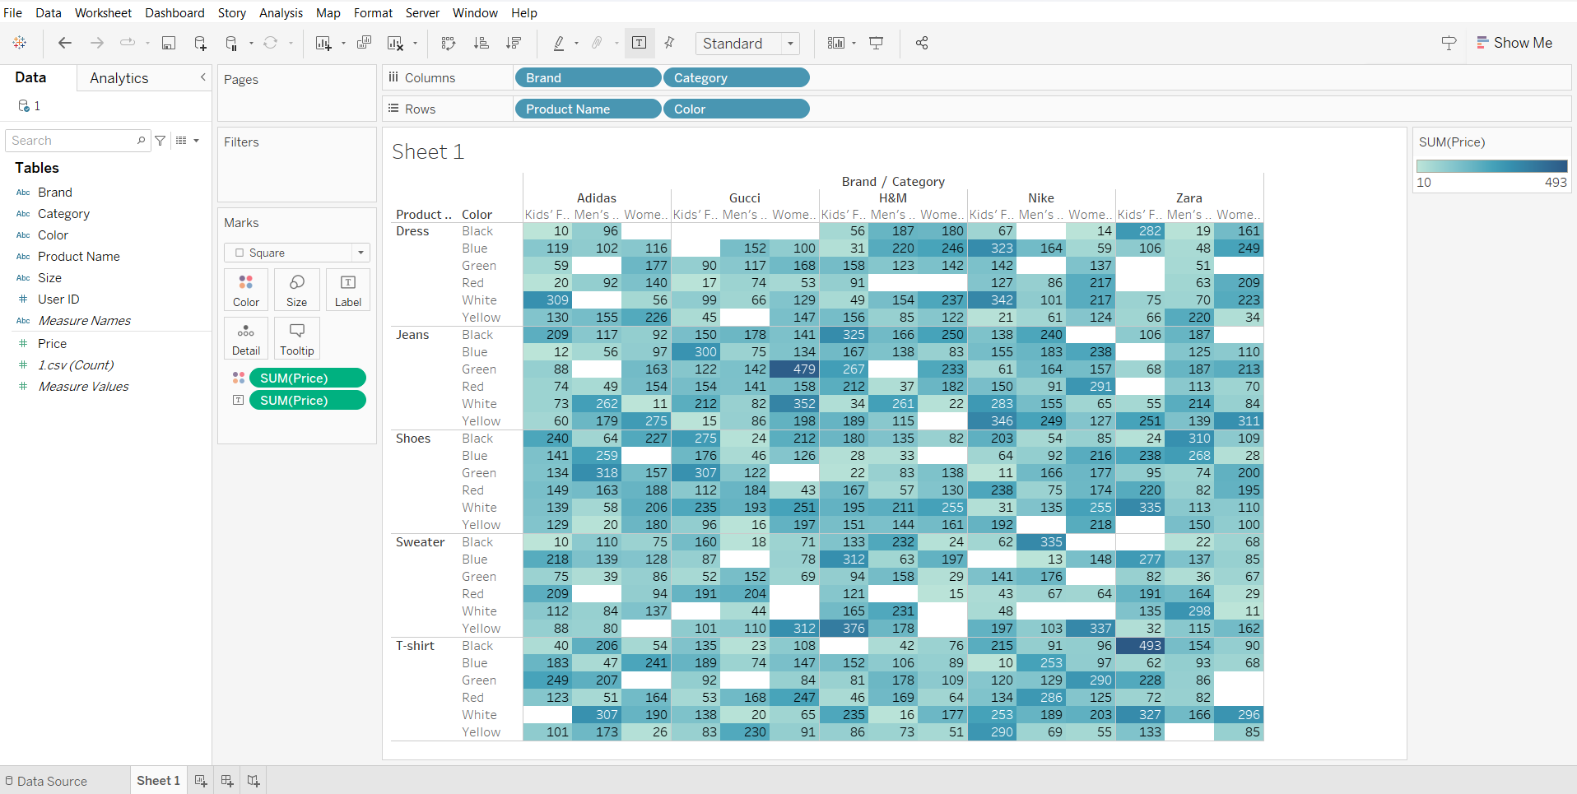

**HEAT MAPS:**

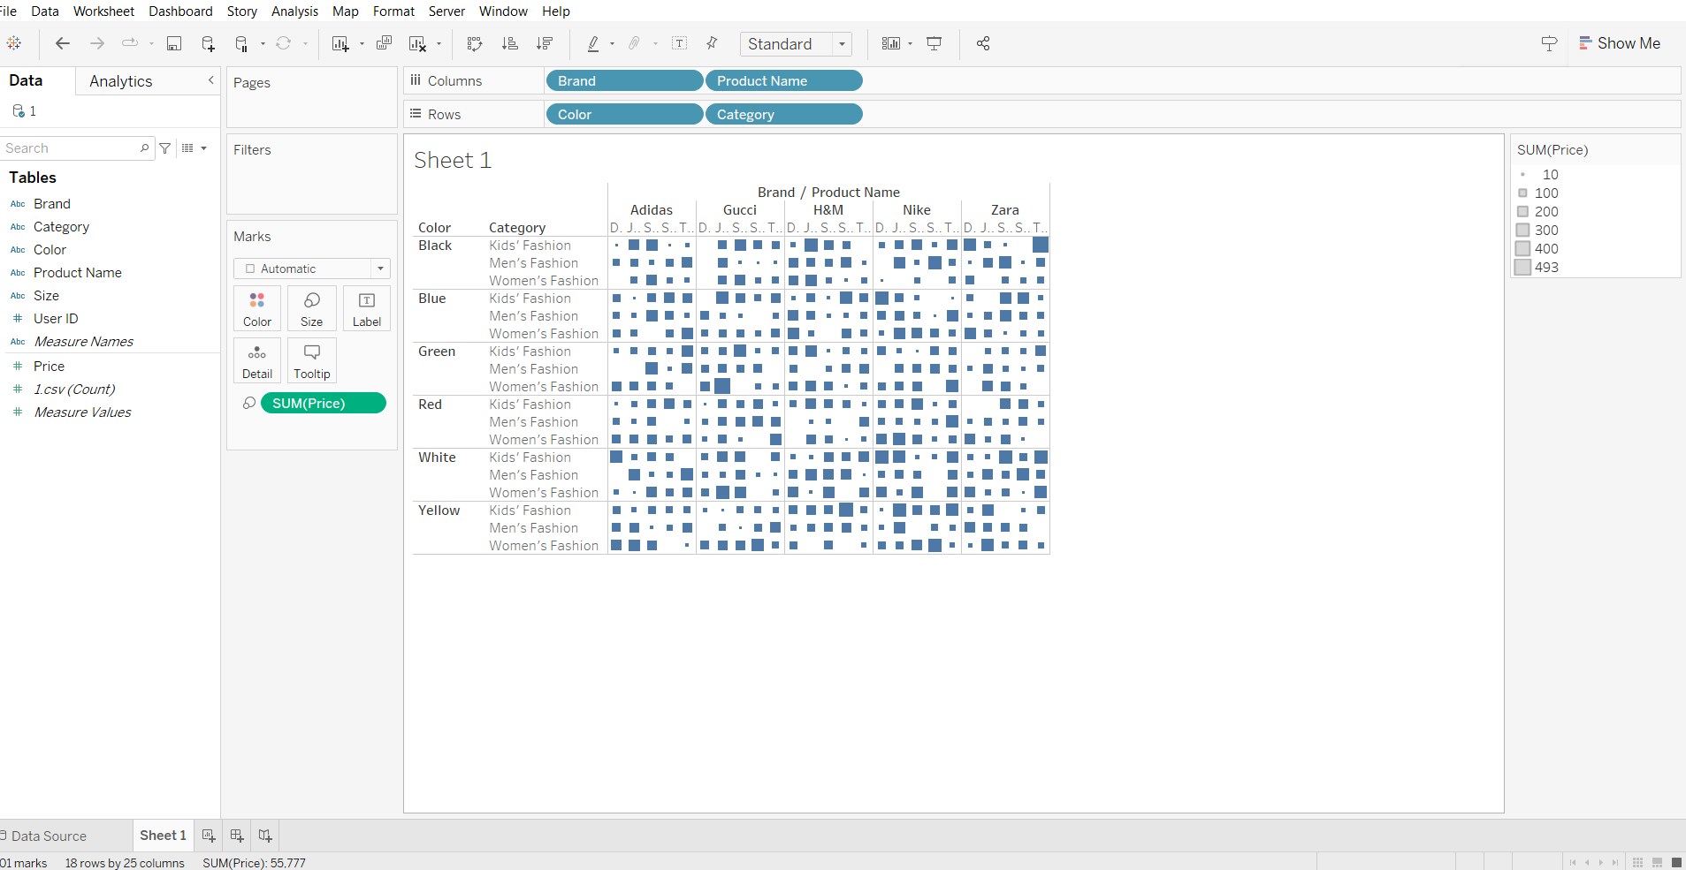

**HISTOGRAM:**

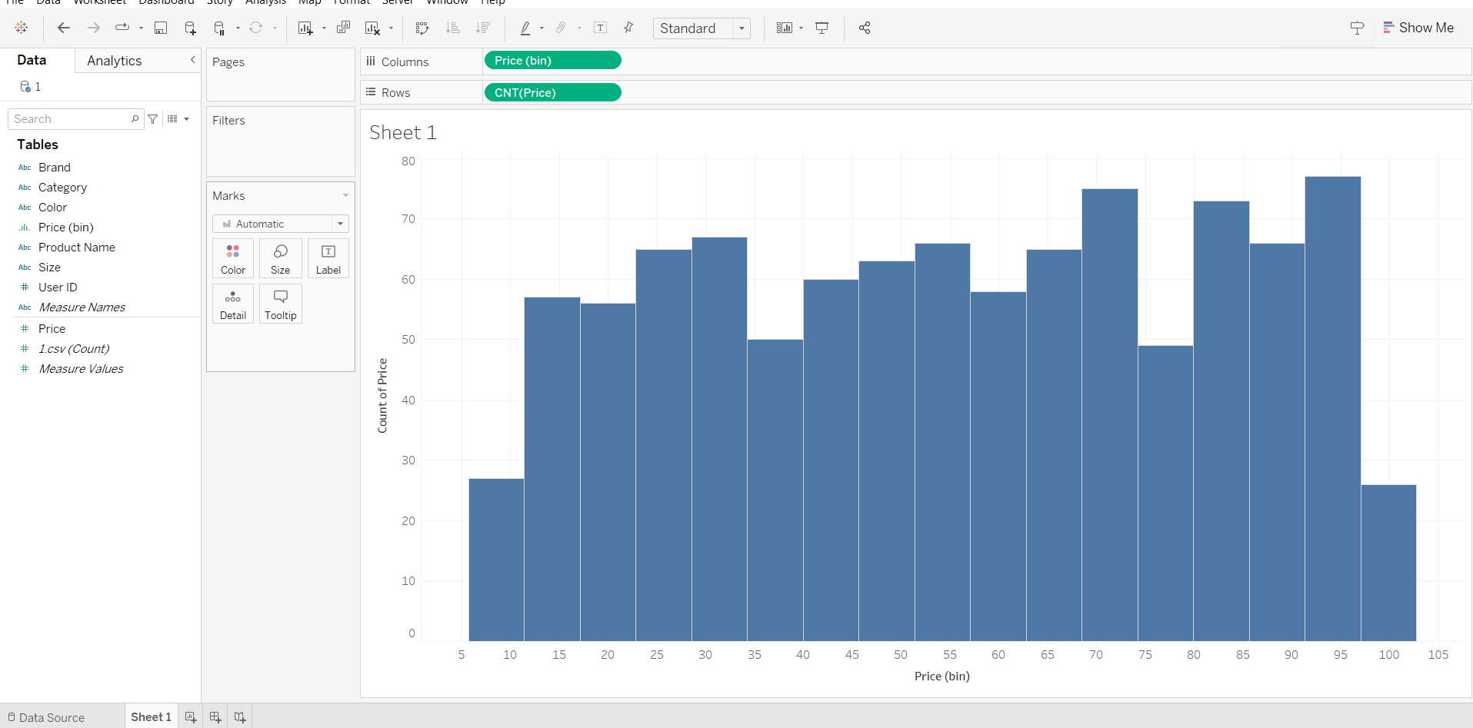

**DONUT CHART:**

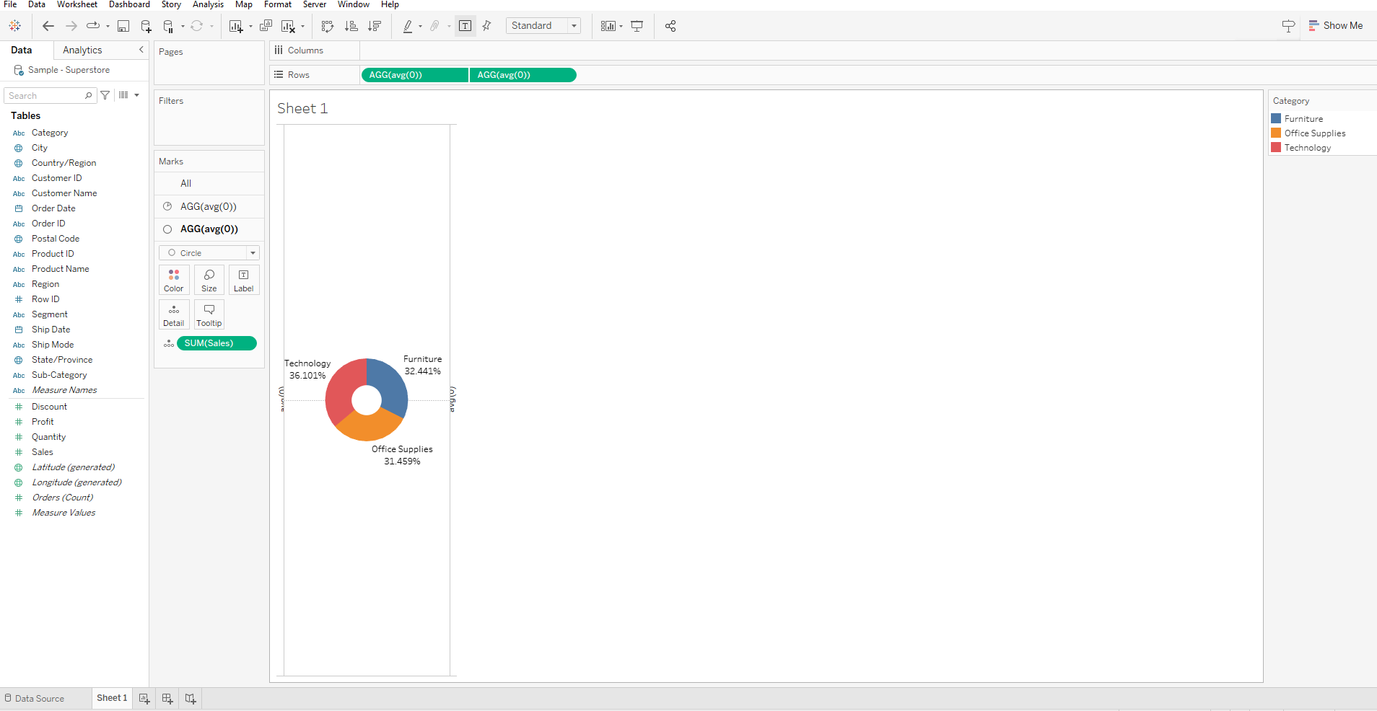

**LOLLYPOP CHART:**

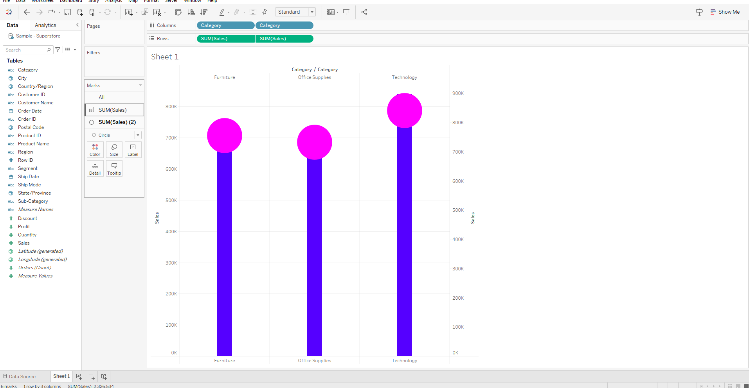

**BOX PLOT:**

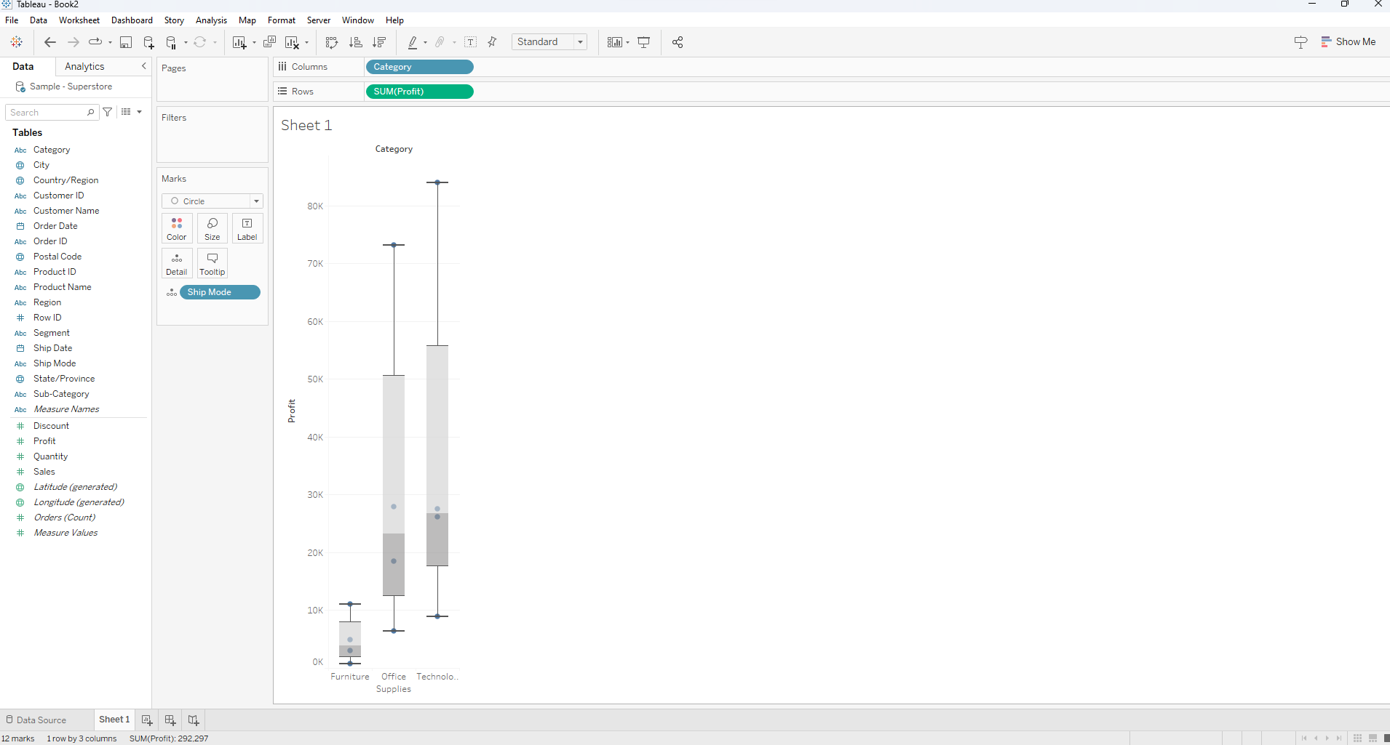

# LINE CHART:

# 

# BUMP CHART:

# 

**FUNNEL CHART:**

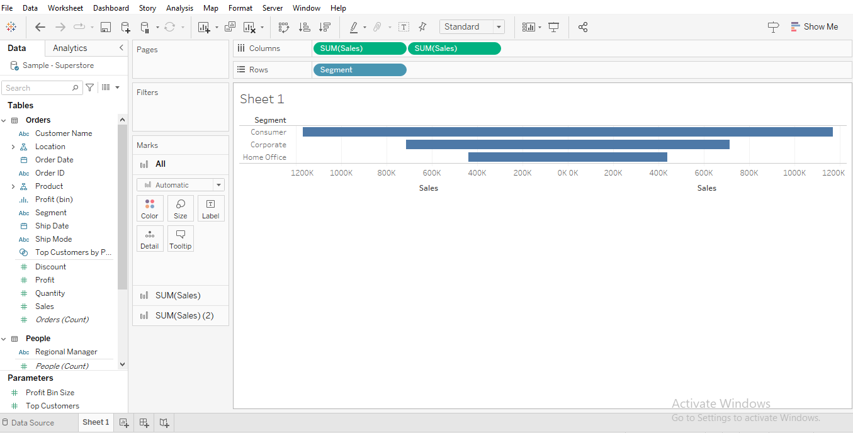

**WATER CHART:**

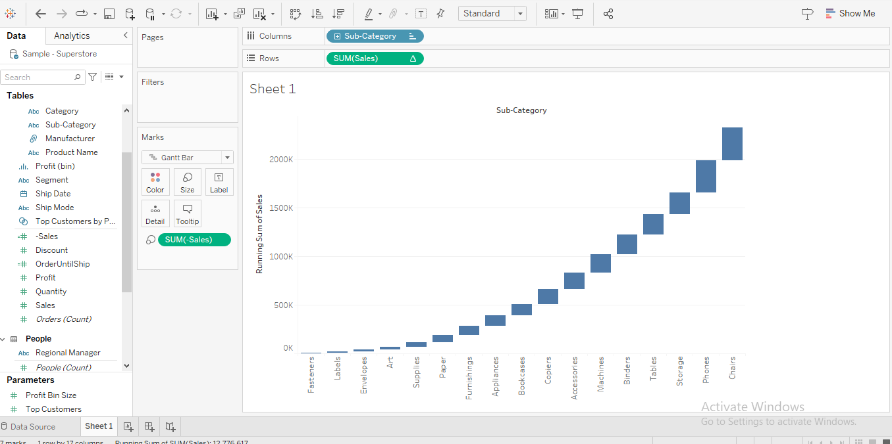

**AREA CHART:**

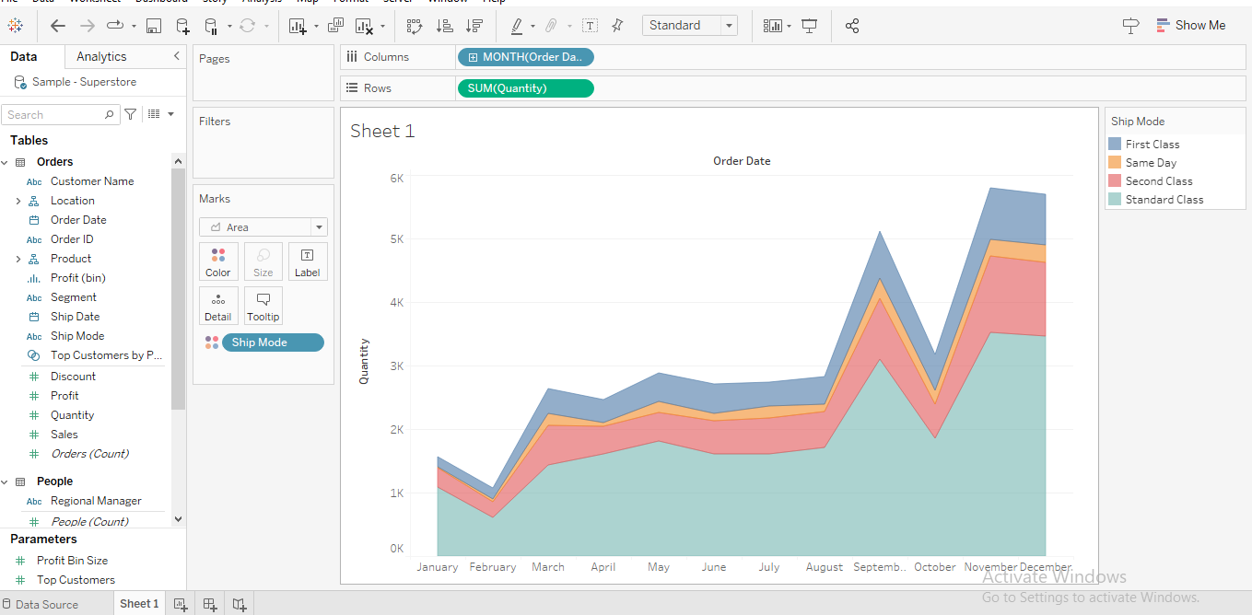

**PARETO CHART:**

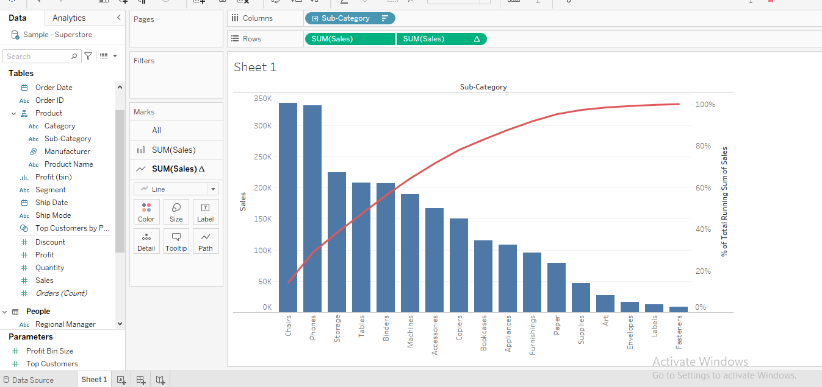

**GANTTCHART:**

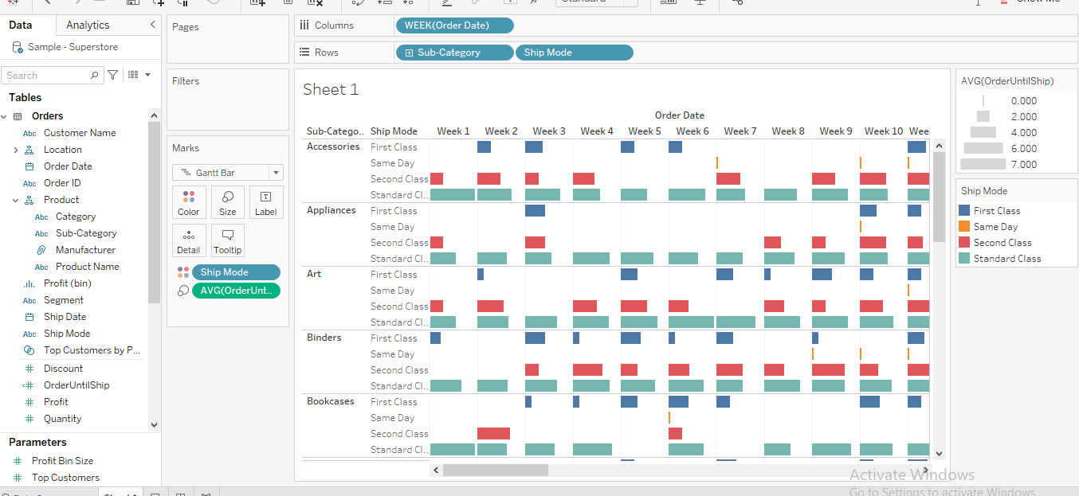

**WORD MAP:**

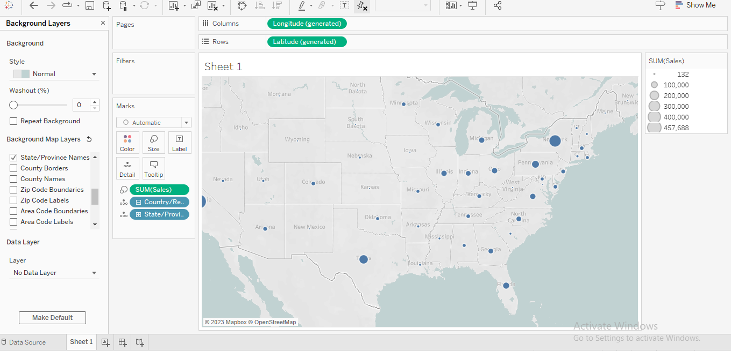

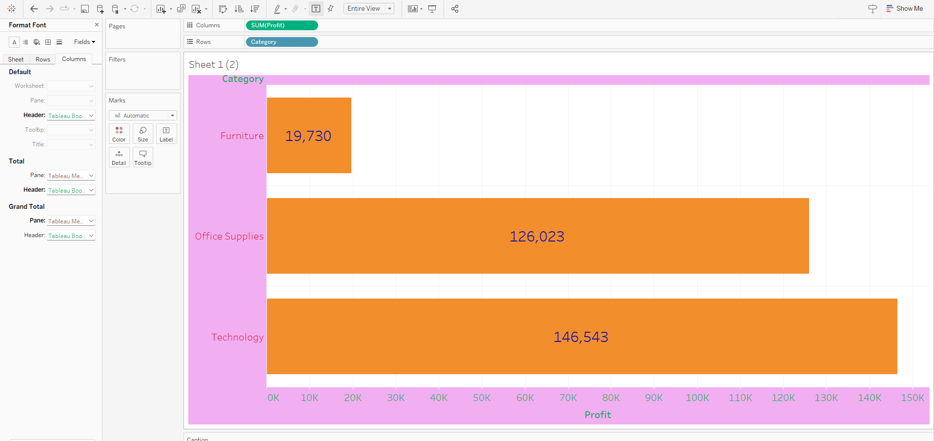

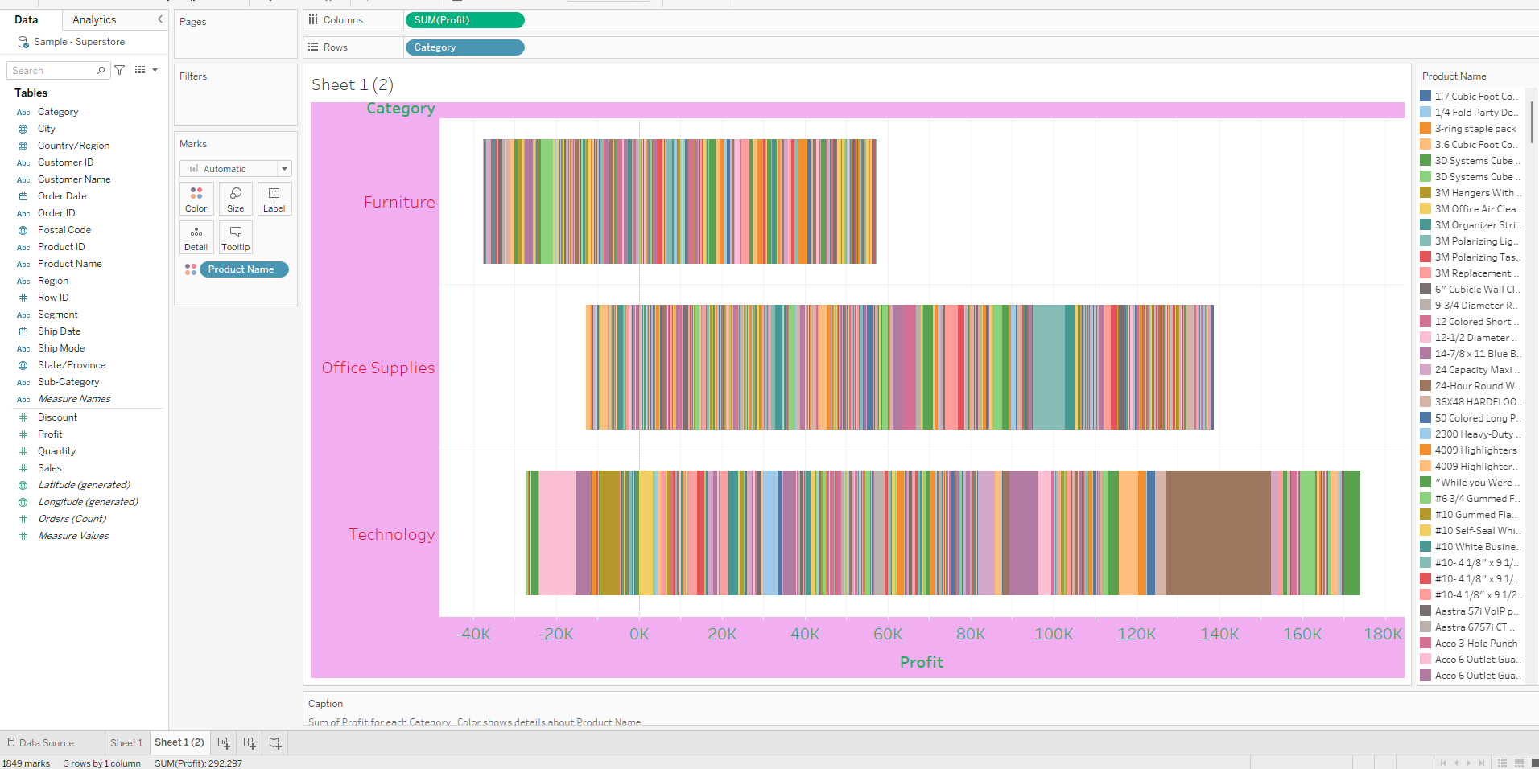

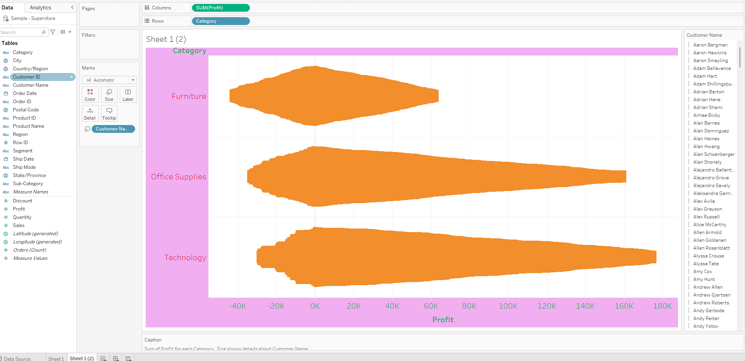

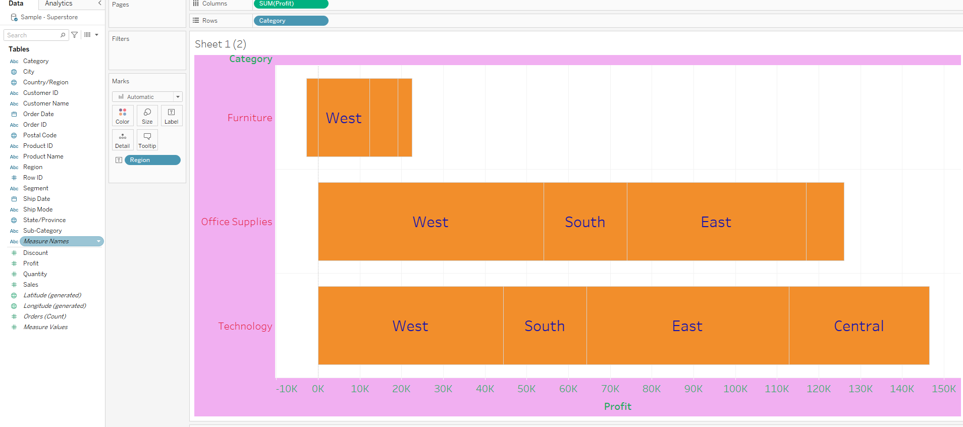

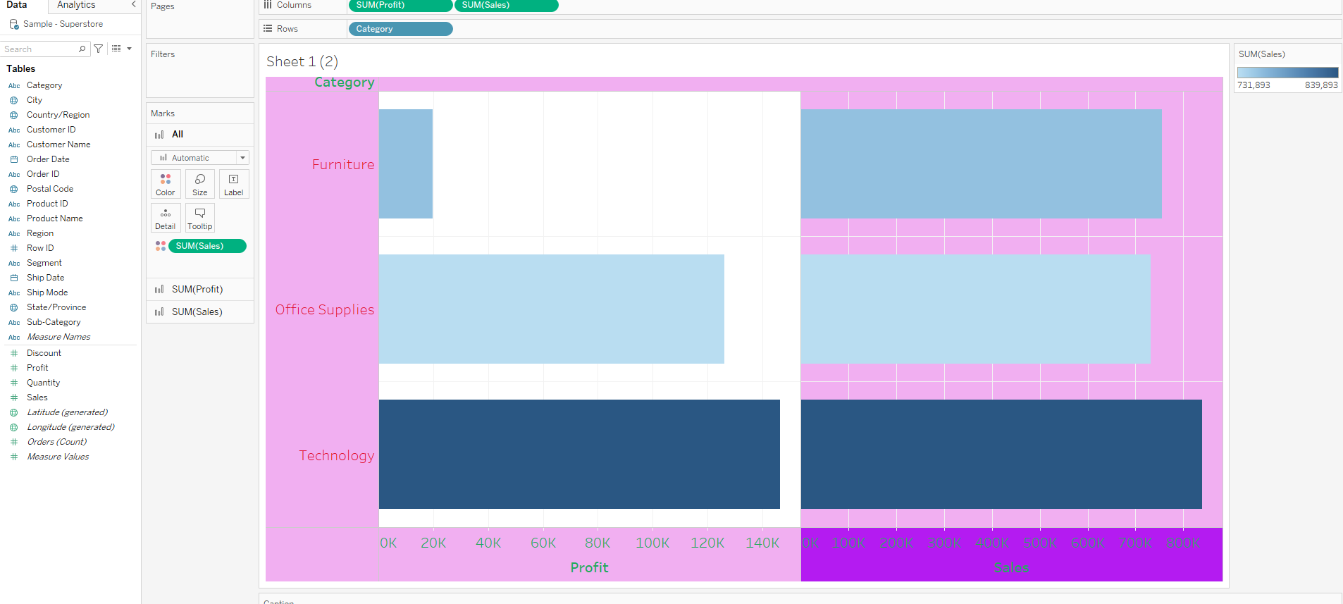

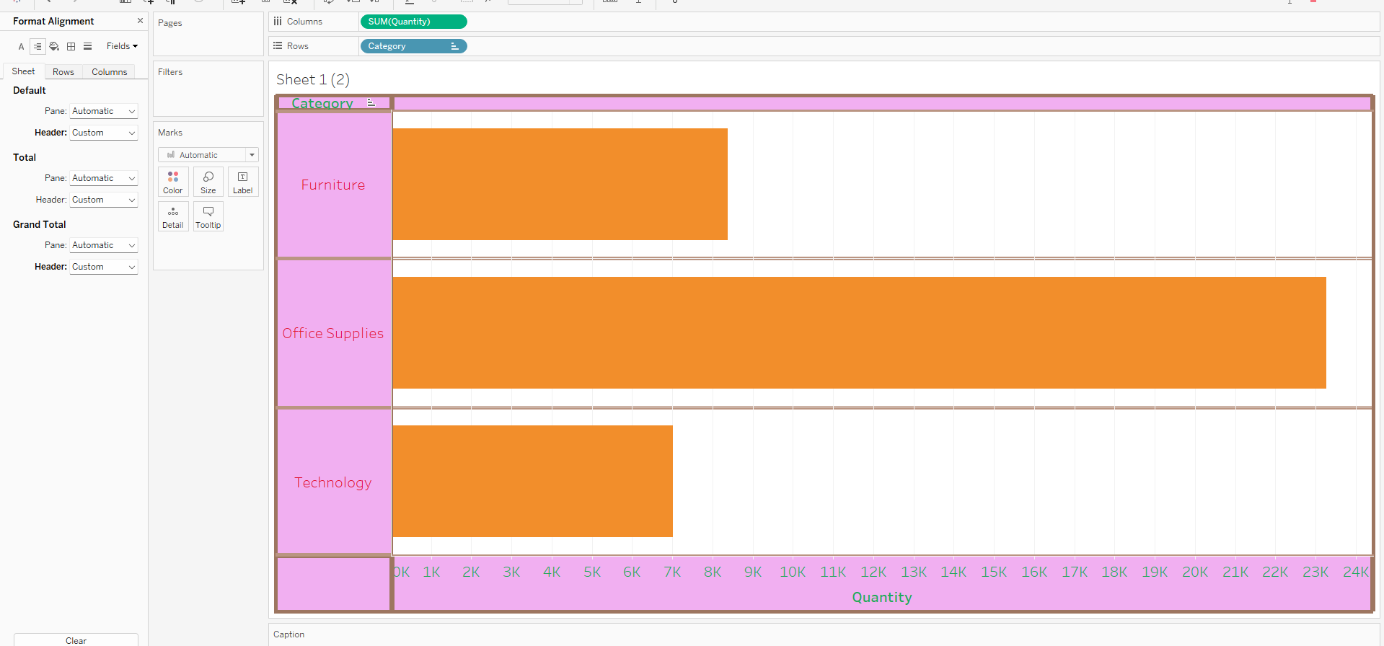

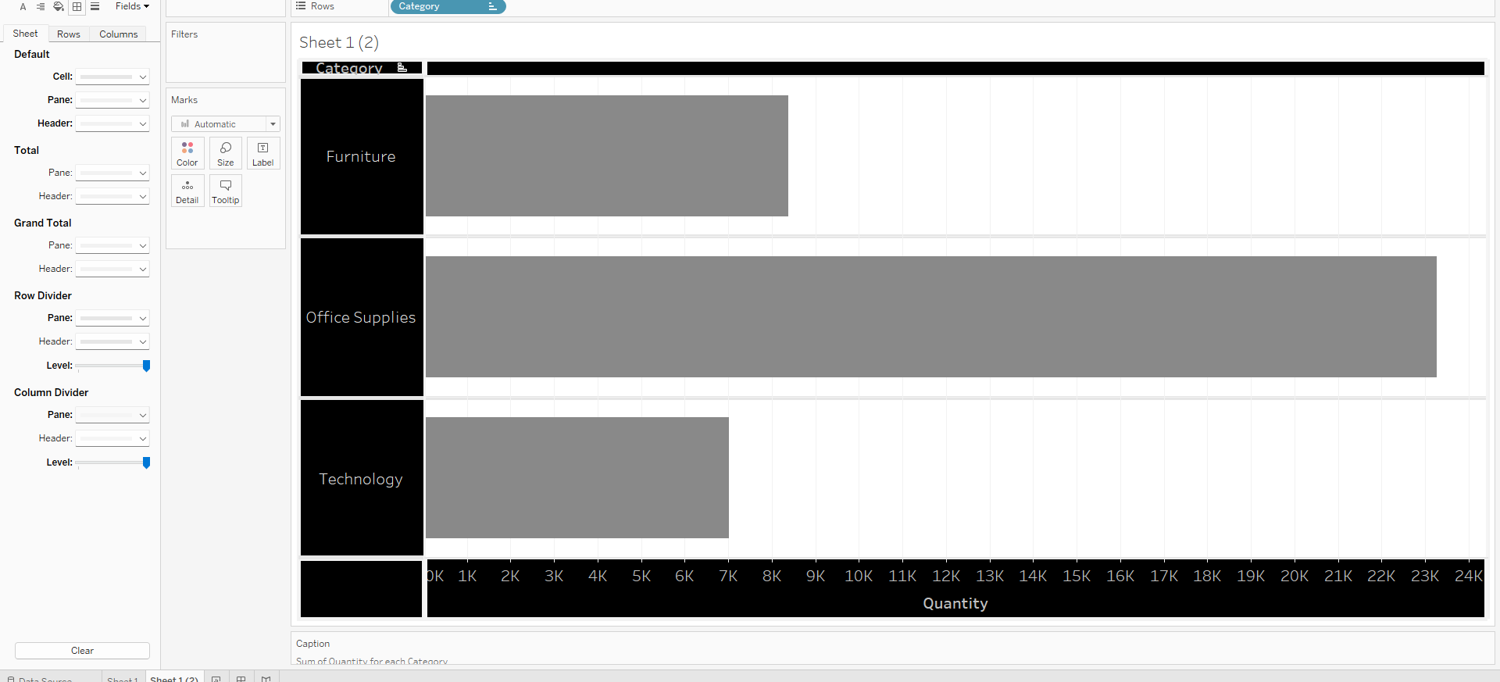

# Conclusion (Students should write in their own words):

# Thus, we learned how to use different types of graph in tableau using the given data.

**Date: _22/08/2023_ Signature of faculty in-charge**

# Post Lab Question:

# What are different data types supported in Tableau software?

# Which chart is most appropriate for visualizing your preprocessed dataset? Justify

# 1] Tableau supports 7 types of data types string values, date values , date & time values , numeric values , boolean values , geographical values, cluster or mixed values.

**2] Scatter charts are primarily used for correlation and distribution analysis . Scatter charts can also show the data distribution or clustering trends and help you spot anomalies or outliers.**

**If you want to compare between values in your dataset- use a scatter plot, bubble chart, or line charts.**

**If you want to compare values, use a pie chart — for relative comparison or bar charts — for precise comparison.**

**If you want to compare volumes, use an area chart or a bubble chart**